Unveiling Spectera
Global events permit Sennheiser customers and media to dive deeper into new wideband wireless technology

Wedemark, 30 September 2024 – On the first IBC show day, 13 September, Sennheiser unveiled Spectera, the world’s first bidirectional wideband digital wireless ecosystem. The day was marked by events in the cities of Nashville, Hong Kong and Amsterdam, with the latter hosting the main event, which attracted 252 participants from a total of 30 nations.

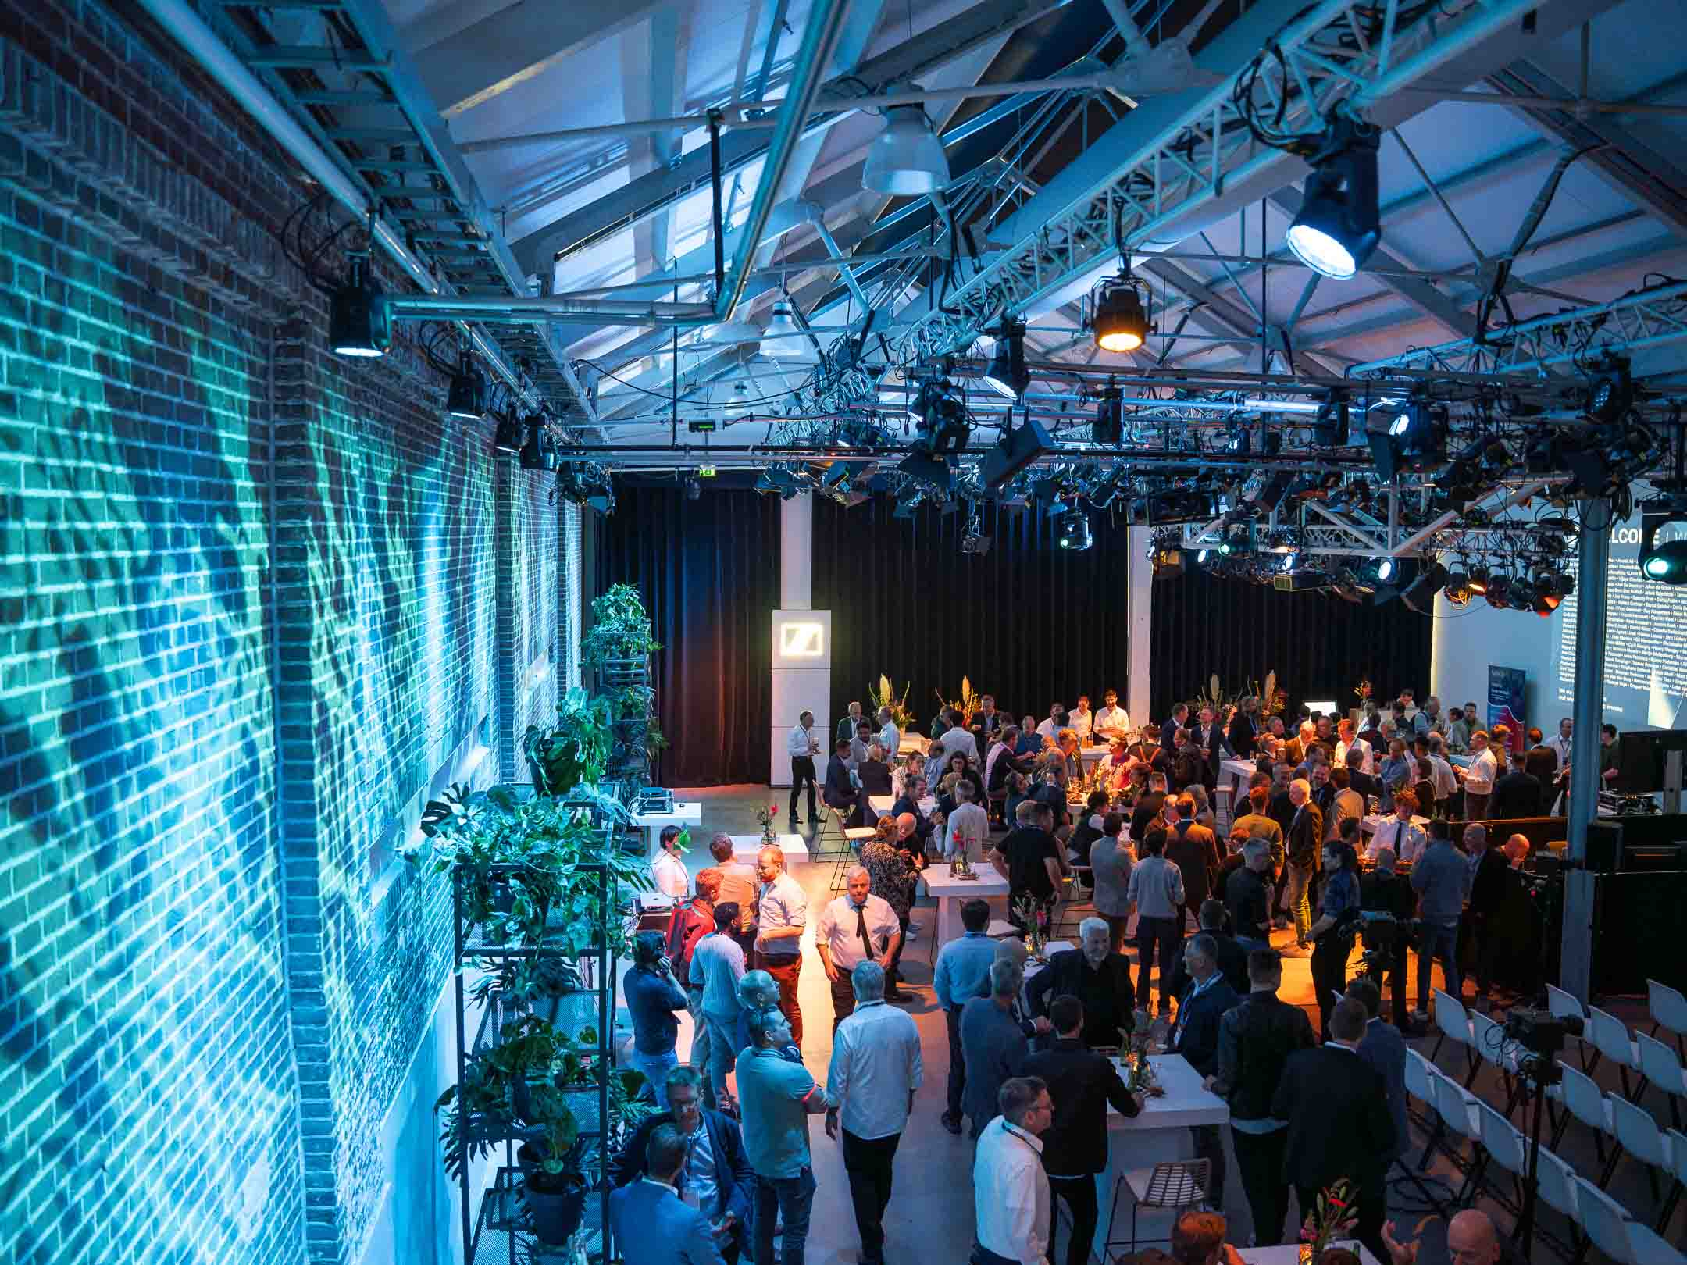 | Amsterdam’s De Hallen Studios, located in a former tram depot, provided a beautiful setting for the Spectera event during IBC

The speakers at the event in Amsterdam’s De Hallen Studios took guests on an exciting journey from Sennheiser’s beginnings in wireless microphone technology in 1957 to today’s game-changing wideband approach. “It’s worth remembering that since 1957, all wireless microphone – and later also IEM – transmissions were narrowband, so Spectera really is a technology shift, for which the frequency regulations of every country needed or still need to be changed,” says co-CEO Dr Andreas Sennheiser.

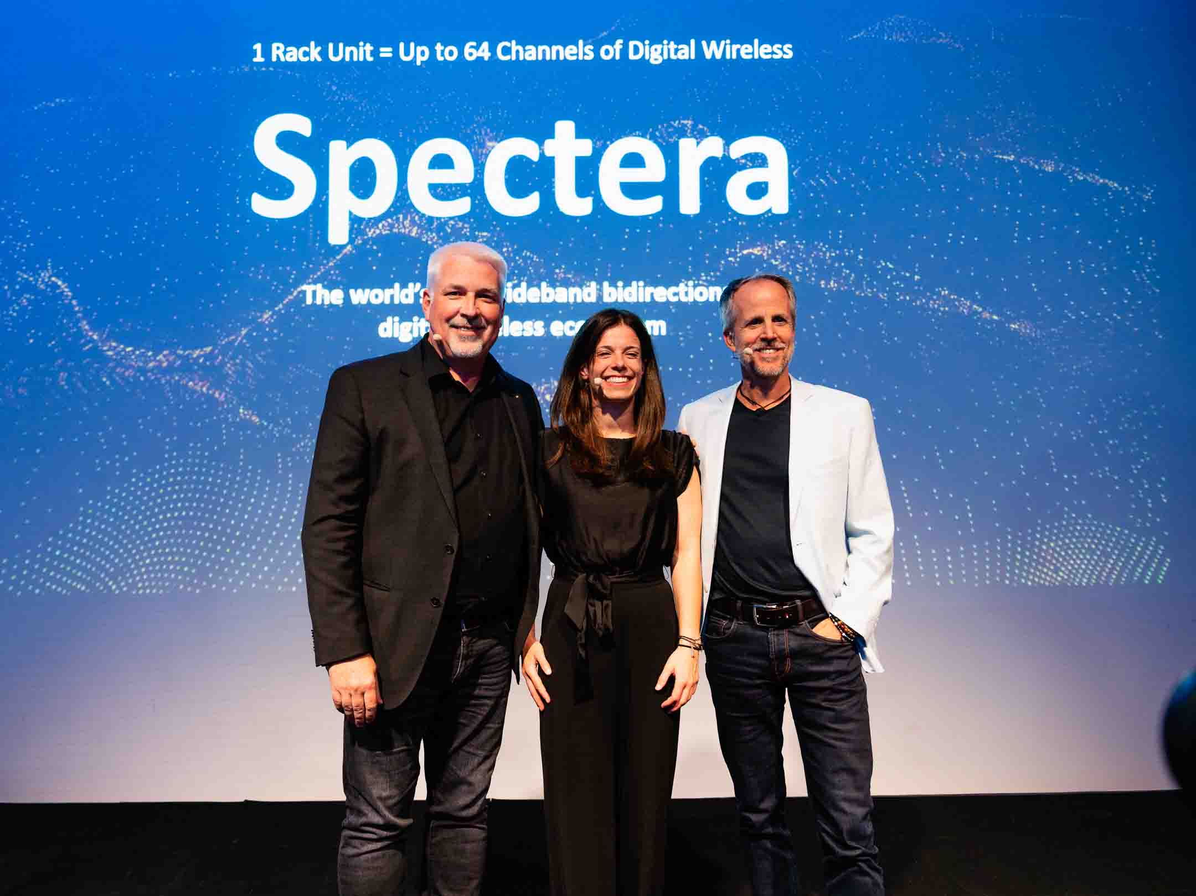 | Speakers Christophe Van den Berghe (Vice President of Sales EMEA), Theresa Vondran (Category Market Manager, Pro) and co-CEO Dr Andreas Sennheiser summarised the many benefits of the Spectera bidirectional wideband ecosystem

After the impactful presentation, which was delivered over Spectera, guests could take a closer look at the ecosystem: Sennheiser’s engineering team manned several trial stations, where they provided deep dives into the new WMAS technology and answered any questions that participants had. Spectera SEK bidirectional bodypacks were at hand to demo the system’s impeccable digital IEM audio quality.

 | 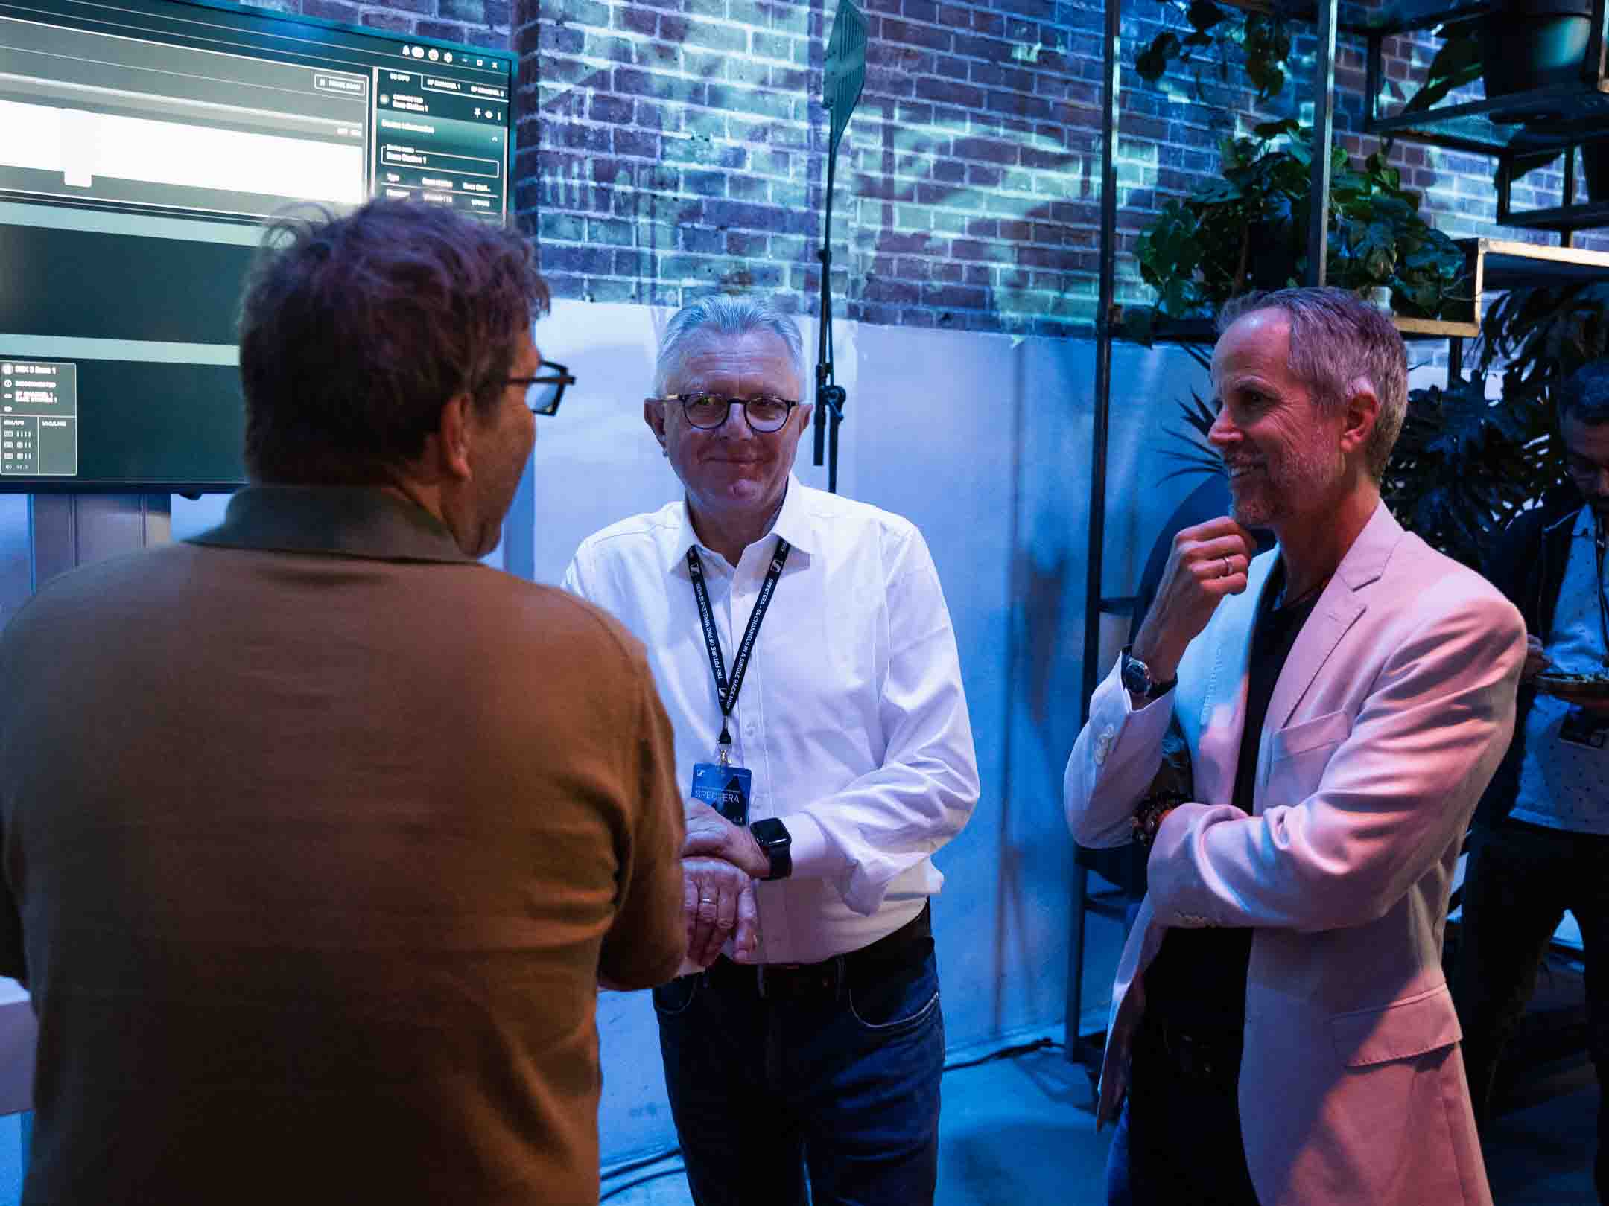
Several demo stations invited guests to learn more about Spectera

“The unveiling of Spectera was a milestone,” says Andreas Sennheiser. “Now is the time to grow the ecosystem together with our customers, and to continue speaking with many more regulatory authorities across the globe. What did our spectrum policy team say recently? ‘We have agreement for WMAS in over 60 countries – still more than 120 to go!’”

(Ends)

Watch a video of the Amsterdam Spectera presentation here.
The high-resolution images accompanying this media release can be downloaded here.

About the Sennheiser brand
We live and breathe audio. We are driven by the passion to create audio solutions that make a difference. Building the future of audio and bringing remarkable sound experiences to our customers – this is what the Sennheiser brand has represented for more than 75 years. While professional audio solutions such as microphones, meeting solutions, streaming technologies and monitoring systems are part of the business of Sennheiser electronic SE & Co. KG, the business with consumer devices such as headphones, soundbars and speech-enhanced hearables is operated by Sonova Holding AG under the license of Sennheiser.

www.sennheiser.com
www.sennheiser-hearing.com

Global Pro Audio Press Contact
Stephanie Schmidt
stephanie.schmidt@sennheiser.com
+49 (5130) 600 – 1275

